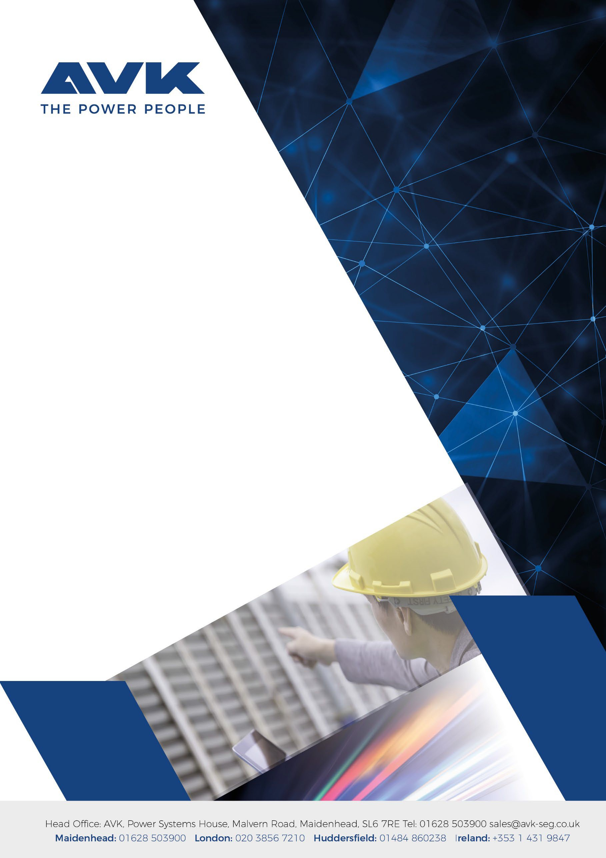
B

QEMS0601 CORPORATE SOCIAL & SUSTAINABILITY POLICY

OVERVIEW

  - It is important to everyone who works at AVK to work for a socially responsible organization. We are committed to making a real and sustainable difference which we have detailed below.
  - We acknowledge that running our business influences society. We particularly have a responsibility to our clients, our employees, and contractors as well as the broader community in which we operate.
  - We are committed to taking responsibility for our actions and encouraging a positive contribution towards improving standards for our clients and employees, minimising our impact on the environment, and improving the quality of the local community.
  - We are committed to providing a safe working environment and promoting a positive culture of health and well-being in accordance with AVK-HR#008 Health & Safety Policy.

- VISION AND COMMITMENT

  - AVK recognises the huge contribution our operations have to the environment and society. We are committed to fostering a sustainable future while prioritising social responsibility. Our vision is to integrate environmental, social, and economic considerations into all aspects of our operations to create a positive impact on society and the environment.
  - We acknowledge the responsibility we have to our clients, employees, contractors, and all communities we work in to not only have a broad understanding of our environmental and social impacts but to put strategies in place to ensure continuous improvement.
  - By introducing a Corporate Social and Sustainability into practice, we are committed, wherever possible, to:
- Spearheading carbon reduction and reducing the impact we have on the natural environment.
- Ensuring we are operating as an ethical business and extend that standard to our entire value chain.
- Working closer with the communities we work in, seeking to better ‘the footprint we leave’ in these communities.
- Taking our supply chain along the journey with us, working on our supplier relations with all suppliers who share our commitment to sustainability and ethical business practices. In the same vein, we will be working closely with suppliers to seek out opportunities to develop products that are environmentally friendly throughout their lifecycle.
- Ensuring we take all our stakeholders on the journey with us and making sure we are transparent with all as we develop sustainability impact reports, with regular updates on all initiatives and reduction targets.
- Increasing our employee engagement is a huge priority for us at AVK. We do not believe that the responsibility lies only with our senior leadership team and environmental team, instead we want all colleagues to have a better understanding of our environmental and social initiatives and have all employed in implementing said initiatives into all areas of the business.

RESPONSIBILITY AND OVERVIEW

  - Our Chief Finance Officer has overall responsibility for our corporate social and sustainability strategy, closely supported by our Sustainability Specialist to implement this policy. Together they will lead in ensuring the systems and controls we have in place are effective.
  - All AVK employees have a role to play in complying with our corporate social and sustainability objectives and are actively encouraged to make suggestions in relation to initiatives. All suggestions should be shared with our Sustainability Specialist.
  - We are fully committed to the highest possible standards of openness, honesty, and accountability. In line with that commitment, in accordance with our Disclosures Policy, we actively encourage all staff members who have serious concerns about any real or perceived departure from the high ethical standard that we set to voice those concerns openly.
  - We are committed to ensuring our policy remains effective. As part of our ongoing commitment, this policy is reviewed at least annually to verify its effective operation. Records of the reviews are maintained, and any necessary amendments are made to the policy, as appropriate.

CONDUCT

  - We aim to adopt the highest professional standards and not to act in such a way as to compromise our organisation’s integrity.
  - We actively promote respect between our staff members in their dealings with each other and with clients and other third parties.

- ENVIRONMENTAL SUSTAINABILITY

At AVK, we understand the critical importance of preserving the environment and minimising our ecological footprint. We are committed to operating in an environmentally responsible manner, continually improving our practices, and promoting sustainability throughout our operations.

  - Principles

    - Resource conservation: we are committed to conserving natural resources, reducing waste generation, and maximising all our resources across all aspects of our generations.
    - Emissions reduction: prioritising reducing greenhouse gas emissions, air pollutants, and other environmentally harmful substances associated with our activities.
    - Biodiversity Preservation: we strive to protect and enhance biodiversity, respecting local ecosystems and minimising our impact on wildlife habitats.

  - Actions and Initiatives

    - Energy Efficiency: actively seek ways to improve energy efficiency in our facilities, products, and services, implementing technologies and practices to minimise energy consumption. To achieve this, we are working towards becoming ‘ESOS Compliant’, this scheme introduced by the UK government ensures organisations in the UK are energy efficient. Under this scheme, we will be required to assess our energy usage every 4 years and consider new opportunities to save energy.
    - Waste Management: adopting efficient waste management practices, emphasising waste reduction, recycling, composting, and responsible disposal of hazardous materials. In line with this, we are exploring waste contractors that align with ‘Zero Waste to Landfill Policy’ where possible. To incorporate this target into our business operations we will be adhering closely to the waste hierarchy of ‘Prevent, Reuse, Recycle, Energy Recovery, Disposal. We work with all employees to educate them on the effect waste has on the natural environment and work with waste contractors that can assist us with this target. This policy will be for all office waste (for offices that AVK have dictatorship over our waste contractor), service waste and projects where AVK is the principal contractor.
    - Water Conservation: implementing measures to conserve water resources, reducing consumption, and implementing where possible water-saving technologies in our operations.
    - Responsible Travel: as an organisation that works nationally, travel is a crucial part of our business, however, AVK are committed to reducing our travel where possible. We will be encouraging colleagues to reduce their travel by monitoring our grey fleet travel by promoting the use of hybrid/remote meetings.
    - Sustainable Supply Chain: collaboration with all suppliers is imperative to our success on our sustainability journey and we will be working closely with our suppliers to further their own sustainability targets.
    - We have started to encourage the production of Environmental Product Declaration forms from our suppliers or at the very least provide sufficient data for TM65 calculations. As we progress in our commitment to becoming Net Zero, we must have a comprehensive understanding of the carbon impact of all items we procure.
    - While we cannot impose on our supply chain to look at how they source their materials, as we set out targets, suppliers that are able to demonstrate eco-friendly materials, use sustainable materials/recycled materials and are actively working towards reducing their carbon footprint will be favoured. Similarly, suppliers working to transition from a Linear economy to a Circular economy and adopting its principles demonstrate better alignment with the direction we are moving in:
      - Eliminating waste and pollution by designing products and processes that minimise or avoid them.
      - Keep products and materials in use by creating loops of circulation, reuse, repair and manufacturing.
      - Regenerate natural systems by restoring, protecting, and enhancing the environment and its resources.

- SOCIAL RESPONSIBILITY

  - Ethical Conduct

Ensuring we are operating ethically is paramount to our ethos at AVK and this expectation is extended to our entire supply chain. We uphold the highest standards of integrity, honesty, and ethical conduct in all our business dealings. To this end, AVK has joined Sedex – an organisation that provides ethical trade tools and services for companies to improve responsible business practices and working conditions in global supply chains. Sedex will support AVK in:
      - Gaining an understanding of our suppliers’ social and environmental performance utilising their assessment tools.
      - Conducting country, sector and site level risk assessments for our supply chain and business.
      - Using their leading methodology, SMETA (Sedex Members Ethical Trade Audit), AVK will gain a better understanding of the working conditions and environmental performance at sites within our supply chain.
      - SMETA audits provide a Corrective Action plan for suppliers to help improve the working conditions and environmental issues from high-risk sites.

  - Community Engagement

As an organisation that works nationally, we work in a diverse range of communities and at AVK it is important that we actively engage and support the communities in which we operate. We recognise our role and responsibility to contribute positively to society beyond our core business activities. We strive to build meaningful relationships, address local needs, and create lasting social impact. To ensure this we have created the initiative ‘The Footprint We Leave’.

  - Our Principles

    - Community Collaboration: through this initiative we are exploring how best to collaborate with local communities, understanding their needs, working together to create solutions that benefit all stakeholders.
    - Sustainable Development: our community initiatives will focus on supporting sustainable development, education, health, reduced inequalities, and social welfare to improve quality of life.
    - Partnerships and Relationships: we want to establish long-term partnerships with local organisations, NGOs, and community leaders to maximise our impact and reach.

  - Actions and Initiatives

- Volunteer Programs: we encourage and support employee volunteerism by offering paid time off for community service activities.
- Skills-Based Support: at AVK we are proud of the diverse skills we have in our workforce and want to use broad expertise to help our communities. We will leverage our knowledge to provide skills-based support, mentoring, and training programs that empower communities.
- Philanthropic Contributions: allocating resources towards philanthropic initiatives that address critical community needs, such as education and environmental conservation.
- Community Engagement Events: organising, sponsoring, and promoting events, workshops and seminars that promote education, sustainability, and community wellbeing.
- Donations: our staff are encouraged to dress down on Fridays and they donate £1 for the privilege. Different charities are nominated monthly by our employees. Below are examples of charities we supported in 2023:
  - Thames Valley Air Ambulance
  - Movember
  - Macmillan’s Cancer Charity
  - Rosie’s Rainbow Fund

  - Diversity and Inclusion

At AVK we want to foster a diverse and inclusive workspace that values and respects differences in perspectives, backgrounds, and experiences. As part of our ethos, we believe diversity strengthens our organisation, fuels innovation, and enhances our ability to serve our customers and communities effectively. Our principles:
- Equal Opportunity: At AVK we provide equal opportunities for employment, development, and advancement, regardless of race, colour, ethnicity, gender, sexual orientation, age, disability, religion, or any other characteristics protected by law.
- Inclusive Culture: We prioritise cultivating an inclusive culture where all employees feel valued, respected, and empowered to contribute their unique skills and perspectives.
- Diversity in Leadership: We strive for diversity in our leadership positions and recognise the importance of diverse voices at all levels of the organisation.
Please refer to the Equality, Diversity, and Inclusion policy for more information.

  - Working Environment
- We recognise that our staff are our most important resource. We actively seek to offer our staff a positive and healthy working environment and ensure that they have rewarding careers and job satisfaction.
- We maintain an Employee Handbook, which sets out the rights and expectations of all members of staff.
- We seek to ensure that all staff have access to the training they need both for their own development and to enable them to deliver a high-quality service. Our procedures in relation to training and development can be found within our Health and Safety Policy Section 4.3

CLIENTS

  - We are committed to delivering a high level of service to all our clients. We understand that our business exists in a very competitive market and to retain our clients we need to deliver a professional and courteous service.
  - Wherever possible, we take steps to promote equal opportunity in relation to access to the legal services that we provide. We take account of the diversity of the communities we serve to ensure that, subject to funding constraints, our services are accessible to all clients.
  - The company is committed to supporting the aims of the Equality Act 2010 and these are reinforced in our AVK-HR#004 Equality, Diversity & Inclusion Policy.

- COMPLIANCE, REPORTING AND CERTIFICATION

  - We endeavor to enter into clear and fair contracts with our suppliers. We commit to the timely settlement of suppliers’ invoices.
  - All our suppliers go through due diligence where they need to submit supporting documentation to prove they are compliant. Suppliers are only confirmed on our Approved Suppliers List once all AVK minimum onboarding requirements are met.
  - We are committed to eliminating unlawful discrimination and to promoting equality and diversity in our professional dealings with suppliers and other third parties.
  - Wherever possible, we aim to support the local economy by contracting with local suppliers.
  - We comply with all applicable laws, regulations, and standards related to social responsibility and environmental sustainability.
  - We maintain transparency in our practices and are working towards increasing the scope of reporting for our social and environmental performance to stakeholders.
  - We communicate this policy to our staff, clients, and subcontractors by means of our website and internal memos.

Ben Pritchard

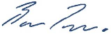

CEO (Signed March 2024)
On behalf of the AVK Senior Leadership Team

